How to write a Questionnaire

# What is a questionnaire?

A questionnaire is simply a list of questions. There are two ways of answering them:-

1. The questions can be read to the respondent - the person answering - by an interviewer who ticks off or writes down their answers. This is called a **structured interview.**
2. The questionnaire can be given to the respondent who fills it in and the researcher collects it later. Or it can be sent and returned by post in which case it is known as a postal questionnaire.

# Why use questionnaires?

* Questionnaires allow data to be collected from a large number of people.
* Questionnaires make it possible to compare respondents' answers to questions.
* Questionnaires are normally used to collect data which can be expressed in statistical form using graphs and tables. They are not very useful if you want very detailed information about respondents' attitudes, especially if you are asking questions about sensitive issues such as racism or divorce. In these cases in-depth interviews might be more effective.
* If you collect data from a large enough number of people who are a representative cross-section of a wider population then you can make statistical statements about that population e.g. 24% of house­holds own or rent a video recorder. Pieces of research which aim to make these kinds of statements are called **social surveys.**

# Which should I use: questionnaire or structured interview?

## Questionnaire

**Advantages**

* Large number of respondents possible
* Respondent has time to consider questions

**Disadvantages**

* Possibility of low response rate (not getting many back)
* Questions cannot be explained to respondent

## Structured interview

**Advantages**

* Interviewer can explain questions to respondent and ask for more detail if necessary

**Disadvantages**

* Manner and appearance of interviewer can affect answers.

# Issues to Consider when using Questionnaires for your Extended Project

1. Why might you want your sample (the people answering your questionnaire) to be as large as possible?
2. What steps could you take to avoid a low response rate for questionnaires you have given out?
3. Work out exactly what you want to find out and only use questions which will help achieve this. What kinds of basic information do you need for instance: age, gender, class?
4. Make your questions as simple and clear as possible, especially if the respondents are going to be completing the questionnaire on their own.

# Questions can be of two types:-

**Open:** where a few lines are given to the respondent to fill in.

**Closed:** where the respondent is given a number of alternative answers to choose from.

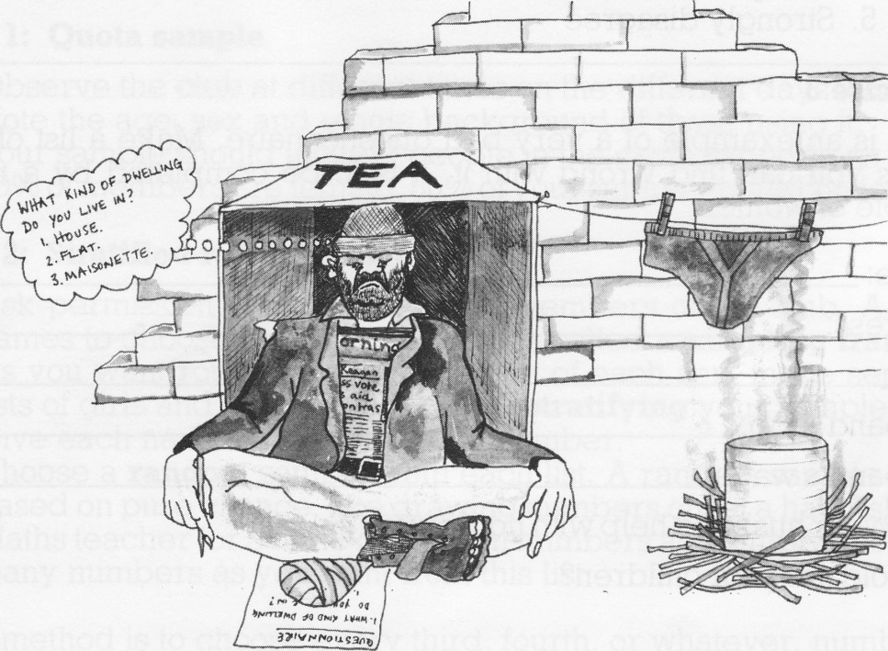The advantage of open questions is that respondents can answer exactly how they want to; they are not forced to choose between your alternatives, as is the man in the cartoon below.

However, if the main purpose of your questionnaire is to produce statistics and graphs, you should use closed questions because they make it much easier to count up the different answers. This is made even easier if you give each alternative answer a number before you give the questionnaires out - this is called pre-coding.

There is a much better way of putting the **closed** question shown in the cartoon:-

*What kind of dwelling do you live in?*

1. *House*
2. *Flat*
3. *Maisonette*
4. *Other (please specify)*

Example of **open** question:-

*What is your opinion of comprehensive schools?*

If you want to find out how strongly a respondent feels about something you can put the question in the following way:-

Please put a circle around the number of the answer that is closest to your view.

*'The showing of violent incidents on television should be more strictly controlled.'*

1. *Strongly agree*
2. *Agree*
3. *Don't know*
4. *Disagree*
5. *Strongly disagree*

# Room for thought

Here is an example of a very bad questionnaire. Make a list of all the things you can find wrong with it. It is to be completed by a random sample of women.

Name:

Address:

Husband's job:

Husband's wage:

Does your husband help with housework? Yes/No

How old are your children? 1-5 5-10 10-15 15-20

Do your children often help you with housework? Yes/No

Do you have joint conjugal roles? Yes/No

You don't enjoy housework do you? Yes/No

# Test Questionnaire

If you are going to write a questionnaire, get a few friends to test it out first. That way if they do not understand it they can tell you and you can then change your questionnaire.